Welcome to Kyiv
A lesson in the 6th class
Objectives:
-to train pupils’ writing habits and skills;
- to develop listening skills;
-to extend pupils’ knowledge about the places of interest of Kyiv;
-to introduce some activities of cooperative learning;
Equipment: pictures of Kyiv, cards with information about Kyiv.
Procedure
I.Introduction
Teacher: Good morning, dear students.
Who is on duty today?
Who is absent today?
What day is it today?
What date is it today?
II. Main Part
You hometask was to make up some poems in the form of “Sankan” about our Motherland – Ukraine. Please, …..tell us .
P1: Nature
Unique, gorgeous
Admires, excites, attracts
Place, where we live
Ukraine
Teacher: Today I want you to learn about Kyiv. But first of all answer my questions: What places of interest do you know in Kyiv?
P1: Kyivo-Pecherska Lavra
P2:Maidan Nezalezhnosti……
GROUP WORK
Teacher: I want you to be divided into groups of four. Each person in the group will receive an information about some place of interest of Kyiv, then he will learn and tell the whole group. Each person will do the same. Then we’ll have information about all sightseeing of Kyiv.
Card 1: Khreschatyk is the main street in Kyiv. It was recently renovated into one of the most scenic and beautiful places that combines the features of a busy business center with the historical architectural design of buildings. On weekends, the traffic is blocked on Khreschatyk, and visitors can enjoy a nice walk right in the middle of the street.
Having changed a lot of names, current name and shape of the modern Maidan Nezalezhnosti were acquired only with obtaining the status of the independent Ukrainian state. After the reconstruction and restructuring of the square there appeared the fountain, new monuments, a magnificent white tower, which symbolizes the independence of Ukraine. Under the square there is the largest shopping center "Globus", offering people of Kiev and visitors the plenty of entertainment and great products.
Card 2: Kyivo-Pecherska Lavra
The Dnipro hills are dominated by the greatest monument of Kyiv, the Kyivo-Pecherska Lavra, built almost nine centuries ago. A complex of churches, masterpieces of architecture by themselves, has been a holy place of worship for devoted Christians. Famous for its catacombs with the saints' relics, Lavra is also called the Monastery of Caves. Museum collections of miniatures and church treasures amaze visitors from all over the world
St. Sophia Cathedral
St. Sophia's thirteen gorgeous golden domes nicely blend with the city skyline. The grandiose ensemble was built by Prince Yaroslav the Wise in the XI century in commemoration of the victory over the Pecheneg tribe. The cathedral became a major cultural and political center of Kyivan Rus and a site for receiving ambassadors from many countries. St. Sophia is famous for its outstanding mosaics and frescoes dating back to the eleventh century.
: St. Michael's Cathedral of golden domes - one of the oldest monasteries in Kiev. The Cathedral is the central temple of St. Michael Monastery. The monastery was founded in 1108 by the grandson of Yaroslav the Wise - the Grand Prince of Kiev Svyatopolk Iziaslavich. The monastery was the burial-vault of Prince Svatopluk and his wife Varbara and others. It was blown up in 1935 and in 1997 – 2000 the monastery was reconstructed according to its appearance in the 18th century.
Card 3: Monument to Cyrill, Methodius, St. Andrew and Princess Olga.
Princess Olga was the first and the only woman in Ukraine history who ruled the state (945-962). In 1919 Olga's monument was broken by the communists into many pieces and buried under the flower bed. For a long period of time it was considered to be lost. Statues of Cyrill, Methodius, and St. Andrew were destroyed in 1923.
The monument was reopened once again and installed in its original place during the reconstruction of the Mykhailivska Square in 1995.
On the slope of the Volodymyr Hill stands the imposing monument to Prince Volodymyr who is also called the Baptizer of Rus. He converted Kyivan Rus to christianity in 988. The bronze statue was erected in 1853.
Card 4: Botanical Garden of. Gryshko in Kiev – this is island of beauty, peaceful and joy for the inhabitants of the business metropolis.
Botanical Garden covers the area of 130 hectares on the right bank of the Dnieper River. The garden grows more than 10 thousand varieties, types and forms of plants of different quality: ornamental plant, vegetables, fodder, medicines and many others, it gathered from all over the world.
Everyone love Botanical Garden : mothers with their children, cyclists, and of course couples in love – everybody can find many interesting places here. And also, this place is a favorite not only for Kiev population, but also for guests.
The funicular (cable car) was built in 1905 and until now it offers quick, exciting, and inexpensive rides from Podil (Lower City) up to Mykhailivska Ploscha (Upper City). The ride is short (about 2 minutes), but it is worth seeing a magnificent panorama of Kyiv and the Dnipro River that uncovers from the Funicular. The cost is the same as the fares in city transport. Children under 7 can have a free ride.
Teacher: I am sure , you have already shared an information about the famous places of Kyiv.
And I ask you to do the following task: answer my questions, please.
Where is the traffic blocked on week-ends? (Khreschatyk)
Where can you find a tall tower, which symbolizes the independence of Ukraine?( Maidan Nezalezhnosti )
What is “ Globus”?( the largest shopping center)
What is a place of worship for devoted Christians?( Kyivo-Pecherska Lavra)
What is another name for Lavra? (the Monastery of Caves)
Who built St. Sophia Cathedral ? (Prince Yaroslav the Wise)
When was St. Michael's Cathedral of golden domes founded? (1108)
Whose monument was destroyed by the communists? ( Princess’ Olga's monument)
Who converted Kyivan Rus to christianity in 988 ?( Prince Volodymyr)
What is called the island of beauty? (Botanical Garden of. Gryshko)
What is “the funicular”? (cable car)
Teacher: Our next task is to label the pictures.
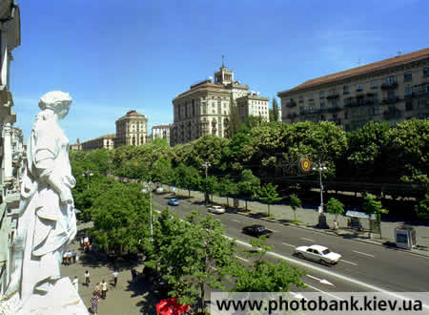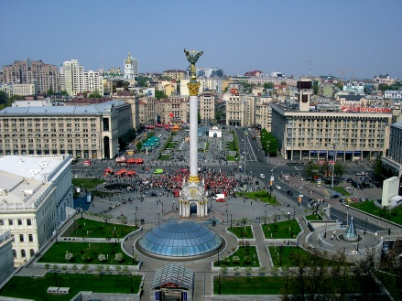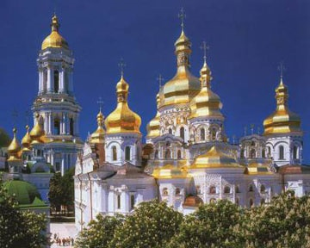
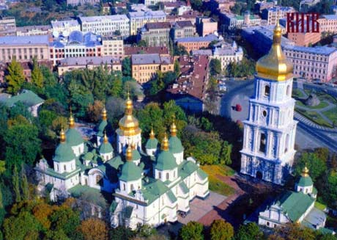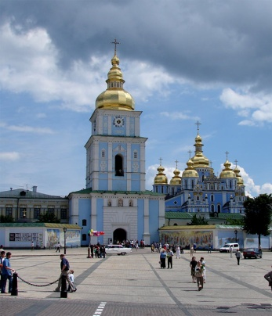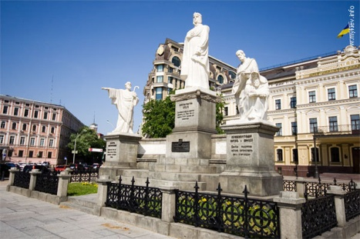

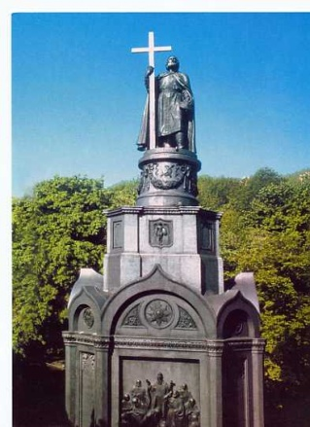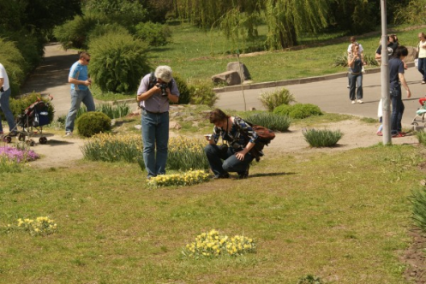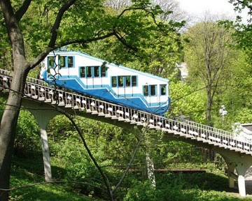

PAIR WORK
Teacher: our next activity will be connected with writing. You must be divided in groups of two. One of you is “a boss” , another- “a secretary”. You can see everywhere in the class some papers with interesting facts about Kyiv and Ukraine. “ A boss” comes to the paper, reads the information and dictates it to the “secretary”. The more information you gather in 5 minutes , the better for you.
“Arsenalna” metro station is the deepest metro station in Europe .Its depth is about 105 meters!

Mikhail Bulgakov said about Ukrainian capital :“There is no more beautiful city in the world than Kyiv".

Ukrainian language took the second place on melodic criteria after Italian.

The shortest city main street is Khreshchatyk Street in the Ukrainian capital Kyiv.

Kyiv was the first ever capital of Kievan Rus, the first Russian state.

Kiev was the largest town in XI century Europe, fifty times the size of London, ten times the size of Paris.

Kyiv is considered the greenest city in the world by UN.

Kiev is considered the greenest city in the world by UN. There's about 20 square meters of greens per resident.
Kyiv celebrated its 1500th anniversary in 1982.

Kyiv is home of THE BIGGEST jet-aircraft in the world.

Kyiv is crossed by THE LONGEST route of Europe E40

Teacher: I propose you to listen to the legend about the foundation of Kyiv and your task will be to make up questions to this text.

Before listening activity: Look at the picture and answer my questions
- How do you think, who are these people?
- What are their names?
- When do they live?

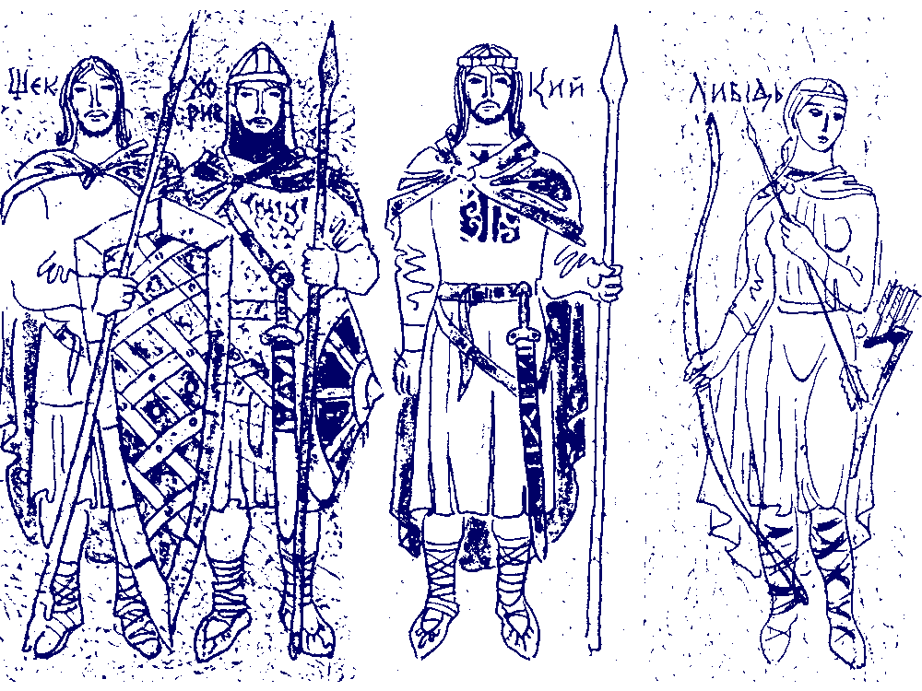
ONCE UPON A TIME there was a royal family of three brothers. One was named Kyi, the second was Shchek, the third Khoriv and they had a beautiful sister called Lybid. They had lost their mother and father to invaders from the East and were searching for a place to make a new home.
When they arrived at the beautiful blue Dnipro River, and saw the seven majestic green hills across the river covered with chesnut trees and flowers, Kyi chose the place as their new home.
Kie and his brothers built a boat and then sailed across the broad and mighty Dnipro River towards the high green bank on the western side. Kie's brothers and sister decided to name the new city KYIV in honor of their strong and brave elder brother, Kie. Thus it was that the City of Kyiv was founded on the last weekend in May, in the Spring of the year 482 A.D.
Kie ruled on the hill which is now called Borichev, Shchek settled on the hill which is now called Shchekovitsa, and Khoriv settled on the third, which after him was called Khorevitsa. And it was thus that they founded the great city over 1,500 years ago.
According to legend here was the very place, where the Apostle Saint Andrew, centuries earlier had raised a cross on the hills of Kyiv and predicted that here a great city would rise one day with many churches to the glory of God.
It was in 988, five centuries after the founding, that King Vladimir Christened his Slavic nation, the Ukrainian people of Rus'-Ukraine. It was here, where the broad street Khreshchatik still marks the place, that the people descended from the hills into the Dnipro River to be Christened into the Christian Church by Greek priests from Constantinople the capital of the Byzantine Empire.

After listening activity: Children make up questions to the text, then read them and ask each other.

P1:Who were three brothers and their sister? (they were of royal family)

P2:What was the name of a man after whom Kyiv was named? (Kyi)

P3:How many hills did they see?(seven)

P4:What trees were there on the hills?(chesnut trees|)……..

III. Conclusion.

Teacher: I see that you have worked today well. All of you have good marks today. You hometask is to find some Ukrainian legends and to be ready to tell them to your friends.

