Теребовлянська спеціалізована школа І-ІІІ ст. № 3
з поглибленим вивченням іноземних мов

КОНСПЕКТ УРОКУ
НА ТЕМУ
"HOUSEHOLD CHORES"
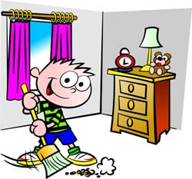

Підготувала
вчитель англійської мови
Ямелинець Л.В.

2013

Theme: Household chores
Subject Matter: Passive Voice
Objectives:
- To revise the vocabulary on the topic;
- To introduce new grammar material;
- To practice the forming and usage of Passive voice;
- To encourage students to work in groups;
- To develop the feeling of duty to do housework.
Equipment: a computer, different kinds of handouts, a CD with Passive Voice video.
PROCEDURE:
I.Introduction
Teacher: Good morning, students. Nice to see you. Let’s start our lesson with our favorite chant.
- Good morning, children.
- Good morning, teacher.
- Are the boys present?
- Yes, they are.
- Are the girls present?
- Yes, they are.
- Is the teacher present?
- Yes, she is.
- Is the board ready?
- Yes, it is.
- Are you ready?
- Yes, we are.
- Can we start the lesson?
- Yes, we can.
Teacher: At the beginning of the lesson I propose to you to revise the vocabulary on the topic and to play the game "BINGO". You are given the papers with the pictures on the topic. I am reading the phrases, if you have the picture which corresponds this phrase you should raise your hand and cross this picture. The first person who crosses all pictures should say "BINGO". He’s a winner of our game.

II. Main Part
Teacher: Thank you very much. I see you know vocabulary well. So, let’s check your hometask. What was your hometask for today?
Pupil 1: Our hometask was to revise irregular verbs and to do the crossword.
Teacher: So, let’s check the hometask. Read the answers in the crossword.one word for every pupil.
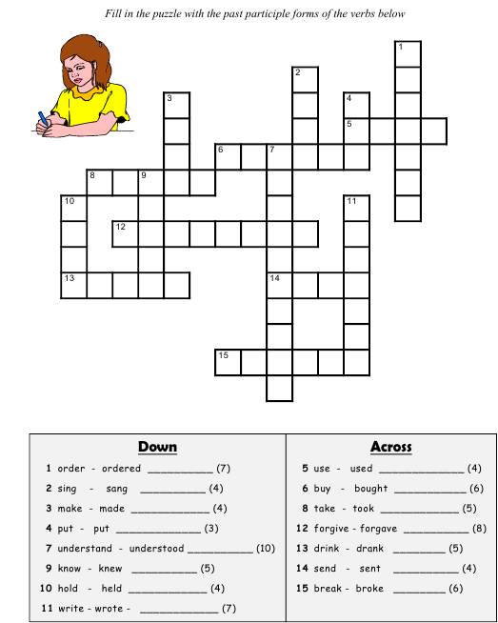

Teacher: As I can see you know the irregular verbs well and now I suppose you are ready to learn new grammar material. So, the theme of our lesson is PASSIVE VOICE.
First of all I want you to listen to the dialogue performed by your friends
A Dialogue
Rita: Darling, I’m home.
Vlad: Yes, my dear. Everything is done.
Rita: What is done?
Vlad: The floor is swept, the carpets are vacuumed, the furniture is dusted.
Rita: Are the windows cleaned?
Vlad: No, they aren’t. The windows aren’t cleaned.
Rita: Are the flowers watered?
Vlad: No, they aren’t. The flowers aren’t watered.
Rita: Is the furniture polished?
Vlad: No, it isn’t. The furniture isn’t polished.
Rita: So, nothing is done.
Vlad: You are wrong. The dinner is prepared.
Rita: Is it?
Vlad: Yes, the fish is fried, the vegetables are chopped.
Rita: Are the dishes washed up?
Vlad: Yes, they are. The dishes are washed up.
Rita: Is the stove cleaned?
Vlad: The stove was cleaned yesterday.
Rita: Is the dishwasher repaired?
Vlad: It was repaired yesterday, but now it doesn’t work again.
Rita: So, not everything is done in this house. You should pay more attention to housework.
Teacher: Passive voice is used when the focus is on the action. It is not important or not known, however, who or what is performing the action.
(subject) (object)
The boy waters flowers.
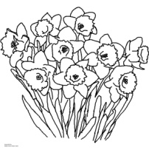
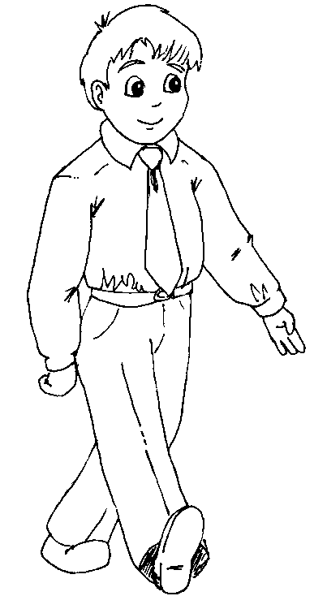
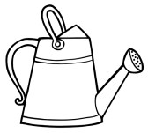
Active Voice

(object) (subject)
Flowers are watered.
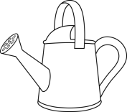

Passive Voice

Past Participle
be
object

Present Past -ed III vf
am was
is were
are

In all the example above the agent is not mentioned. We do not know it.
If we want to say who planted the flowers we mention the agent at the end of the sentence and use the preposition by.
Flowers are watered by the boy.

Teacher: And now look through the dialogue and find the verbs used in passive voice.(is cleaned, are prepared, isn’t washed). Let’s have a practice. Put the words in the correct order.
Pair Work
Writing
Teacher: Look at the pictures and write the phrases of the conversations.

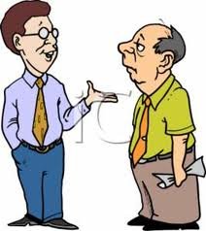
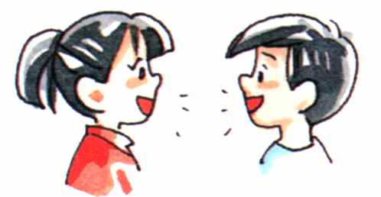

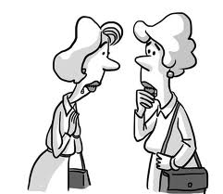
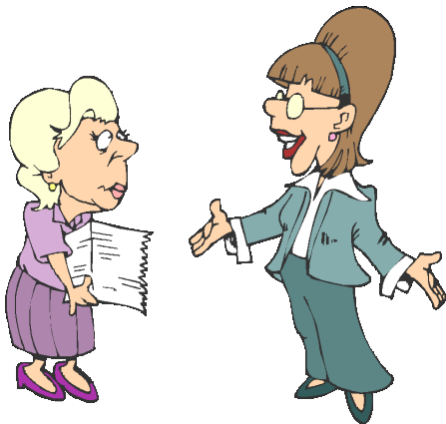

Listening
Teacher: You wrote a lot and I’m sure your fingers are tired, so I propose to you to watch the video and to listen to the poem. Be very attentive, please.
(Appendix "Listening")
Tapescript
The wind shook the house,
The house was shaken.
We took what we could
Not everything was taken.
We lost our pets,
And that day they were not found.
The wind broke down our house,
It was thrown to the ground.
Then we built a new house,
It was built too fast to tell.
We did the work together,
It was done very well.
We invited all our friends,
Our friends were invited.
All of them came with presents,
We were happy and excited.
After-listening activity
Teacher: And now your task is to fill in the gaps with the necessary forms of the verbs.
Student’s paper
The wind shook the house,
The house was________.
We took what we could
Not everything was_________.
We lost our pets,
And that day they were not______.
The wind broke down our house,
It was thrown to the ground.
Then we built a new house,
It was_______ too fast to tell.
We did the work together,
It was________ very well.
We invited all our friends,
Our friends were _________.
All of them came with presents,
We were________and excited.

Reading
Before-Reading activity
Game "Microphone"
- Do you like housework?
- What do you do about the house?
- Do you help your mum? What do you do?
- Does your dad help your mum?
- Who washes up in your family?
- Who cooks better: men or women?
- Who looks after children better: men or women?
Reading
MEN OR WOMEN?
There are stereotypical responsibilities of the husband, the wife, and the children in a family. It is said that the wife’s responsibilities are, basically, to do everything, as far as I can see... to make the beds in the morning, cook the breakfast, and then when the children go to school and the husband goes to work, to start washing the clothes, then tidy up the kitchen, do the washing up, clean the kitchen, go shopping and buy the food for the week, and then put out the washing. If she has a garden, she can hang the washing out on a washing-line - and then tidy up the living room, do the “hoovering” (the vacuum cleaning), and tidy the children’s bedrooms, although I think it should be the children’s responsibility, really, to keep their own bedrooms tidy.
The typical role of a husband, I suppose, is that during the week he goes out to work and earns money for the family. Maybe, at the weekend, he cleans the car and does more technical things around the house, like changing fuses and putting up shelves. It’s also seen as his job to put up the wallpaper, paint the walls, and maybe also to work in the garden, mowing the lawn, cutting the hedges, trimming the rosebushes, etc.
I think it’s becoming much more balanced these days, as quite often the wife goes out to work too, and, of course, when she comes home from work she doesn’t want to have to start doing the vacuuming immediately. Some men are more willing to iron their own shirts and sew on buttons than others, but I think, nowadays, they’re quite often willing to help out with the household chores, such as cooking or washing up the dirty plates after the meal.

After-reading activity
men women

Game "Tree of ideas"

Teacher: You’re given some cards with phrases. Read them and glue on the side of the heart who usually does this kind of work. E.g. Washing the car is usually done by men.
cooking | making the bed | doing lessons with children
washing the clothes | tidying up the kitchen | going shopping
raking the leaves | shoveling the snow | putting up shelves
working in the garden | strolling with baby | mowing the lawn
planting flowers | hoovering | cleaning the car

Speaking
Teacher: And now we have a very interesting task- compare and contrast two pictures. Some phrases will help you to complete the sentences.
II. Conclusion
Teacher: Ok, dear children. I see you worked well today. Do you like the activities you were doing during this lesson? What activity do you like most of all? At the end of the lesson I propose to you to read the poem "What are little girls made of?"
What are little girls made of?
Sugar and spice,
And all things nice,
That’s what little girls are made of.
What are little boys made of?
Slug and snails,
And puppy dogs’ tales,
That’s what little boys are made of.
Homework
Teacher: So, your hometask for tomorrow is to write a similar rhyme to describe men, women, kids, pupils, or any other group you like.
Evaluation
Teacher: Thank you very much for your work today. Your marks are…….., because……… Our lesson is over. Good bye.

